Title | Contractor EHS & Security Handbook – WI
Series | 400 General Safety
Specification Number | GS-441.2

Table of Contents

1.0 Purpose 3

2.0 Scope 3

3.0 Definitions 3

4.0 Compliance 4

5.0 Emergencies 4

6.0 Safety Analysis 4

7.0 Training 5

7.1 Equipment and Tool Training 5

7.2 Site-specific Training 5

7.3 Documentation 5

8.0 Unique or emphasized EHS Program Contractor Responsibilities and Requirements 5

8.1 Barricades 5

8.2 Chemical Use 5

8.3 Competent Person 6

8.4 Confined Spaces and Permit-Required Confined Space Entries (GS-411) 6

8.5 Cranes, Hoists, and Slings (GS-434) 6

8.6 EHS Walkthroughs 6

8.7 Electrical Safety (GS-421) and Interruption of Electrical Service 7

8.8 Equipment and Tools 7

8.9 Fall Protection (GS-431) 7

8.10 Hazard Communication (CHEM-911) 7

8.11 Hazardous Energy Control 8

8.12 Hazardous Materials and Hazardous Waste 8

8.13 Hearing Protection and Noise Control 8

8.14 Hot Work (GS-412) 8

8.15 Housekeeping 8

8.16 Incident Reporting and Notifications (IM-621) 8

8.17 Inspections (IM-613) and Audits 9

8.18 Ladders (Portable) (GS-432) 9

8.19 Lasers (OH-344) 9

8.20 Life and Fire Safety 9

8.21 Lock Out – Tag Out (LOTO) (GS-422) 10

8.22 Material and Equipment Shipment and Storage 10

8.23 Motor Vehicles (Including Forklifts, Scissor Lifts, Golf Carts, and Personnel Lifts) 10

8.24 Non-Destructive Testing (NDT) 11

8.25 Personal Protective Equipment (PPE) 11

8.26 Petroleum Contained in Equipment 11

8.27 Radios and Other Communication Devices 11

8.28 Road Maintenance 11

8.29 Roof Safety 11

8.30 Safety Meetings 11

8.31 Smoking 12

8.32 Spills and Leaks 12

8.33 Utilities and Sanitation Requirements (Construction Sites) 12

8.34 Water Pollution Control 12

9.0 Records 13

10.0 Security and Site Access 13

Document Revision History 14

Purpose
The Handbook outlines unique Cree Lighting requirements or regulatory points of emphasis, reflecting specific hazards or concerns at this site, but is not intended as a comprehensive list of contractor responsibilities and obligations.

Scope
This Handbook applies to all contractors, sub-contractors, service/technical representatives, vendors, and suppliers performing work or providing services at Cree Lighting facilities in Wisconsin, including Econolight. Unless otherwise specified, the contractor responsibilities indicated in this document refer to all the above. This Handbook will refer to “contractors” in the first-person as “you” where appropriate.
Note: 1) Cree Lighting is now a separate company from Cree, Inc. 2) The safety and security requirements of Cree Lighting may be different from those of Cree, Inc. 3) If you are a contractor who wants to perform work for both Cree Lighting and Cree, Inc., you will be required to complete all applicable safety and security requirements for both businesses. 4) If you are a level 1 contractor who wants to perform work for both Cree Lighting and Cree, Inc., you will be required to complete the safety information worksheet and be assigned a color rating for both companies. 5) The color rating that Cree Lighting assigns to you may be different from that of Cree, Inc.

Definitions
  - Authorized Employee – A person who locks out or tags out machines or equipment in order to perform servicing or maintenance on that machine or equipment.
  - Confined Space – A space that is:
- Large enough and so configured that an employee can bodily enter and perform assigned work;
- Has limited or restricted means for entry or exit; and
- Is not designed for continuous employee occupancy.
  - Consultant/Contractor – Person or organization who performs work at a Cree Lighting facility who is not a visitor, Cree Lighting employee, or temporary worker.
  - Hazardous Waste – Waste that poses substantial or potential threats to public health or the environment. In the United States, the treatment, storage, and disposal of hazardous waste are regulated under the Resources Conservation and Recovery Act (RCRA). Hazardous wastes are divided into two major categories: characteristic wastes and listed wastes. Please refer to ENV-241.
  - Hot Work – Work involving electric or gas welding, cutting, brazing, or similar flame or spark-producing operations.
  - Level 1 Contractor – Performs work on production or support equipment or has the potential to come into contact with significant hazards.
- Level 1 contractors are required to be rated in accordance with this procedure.
  - Level 2 Contractor – Contractor who is not exposed to significant hazards. This typically includes office temporary workers, delivery personnel, sales representatives, vending machine suppliers, etc.
- Level 2 contractors are not required to be rated in accordance with this procedure.
- Level 2 contractors need to check with security to see if there is any additional paperwork to complete.
  - Lockout/Tagout – The placement of either a lockout or tagout device on an energy isolating device, in accordance with an established procedure, that ensures that the energy isolating device and equipment being controlled cannot be operated until the lockout or tagout device is removed.
  - Non-Destructive Testing – The process of inspecting, testing, or evaluating materials, components, or assemblies for discontinuities, or differences in characteristics without destroying the serviceability of the part or system.
  - Outside Only (Level 1 or 2) – A contractor who needs access to controlled Cree Lighting property but does not need access into buildings. These contractors may be Level 1 or Level 2. This designation includes lawn maintenance, road service contractors, building construction contractors, etc.
  - Sponsor – The Cree Lighting employee assigned by management to be the contractor’s or service vendor’s contact while on the job.
- Contractors and consultants working for a Cree Lighting sponsor may manage or oversee contractors and projects.

Compliance
You are expected to comply with applicable federal, state, and local laws and regulations. Violating the requirements in this Handbook may result in termination of the contract or your removal from the site. Observed deficiencies may be formally tracked and disseminated to other parties outside of Cree Lighting.

Emergencies
  - During weekday hours of 6 am and 2 pm (Central Daylight Time), call security at (262) 721-1400 or Ext 1400 to report emergencies. To report an emergency occurring outside these hours, call 911.
  - Before starting a job, determine the correct evacuation area with your sponsor, and ensure that if the job site changes, the evacuation area is updated for the new job site.
  - Have a process in place to perform a headcount and notify either your sponsor or security if any contractor employees cannot be accounted for.
  - Contractors must provide their own supplies, trained personnel and procedures for first aid/CPR as deemed necessary by their company or regulation (e.g. Electrical Safety Standard).
  - In the event of a fire alarm (horn and white strobe), evacuate the work space or building immediately.
  - Upon evacuation, escorted contractors must stay with their escort. Non-escorted contractors must assemble at their designated assembly area.
  - Follow the instructions of Cree Lighting officials during emergencies.

Safety Analysis
  - A safety analysis of the job is required before work begins to identify hazards and implement steps to mitigate or remove the hazard. Examples include the following formats:
- JSA - job safety analysis (GS-402A) | - CTR - critical task review (GS-402B)

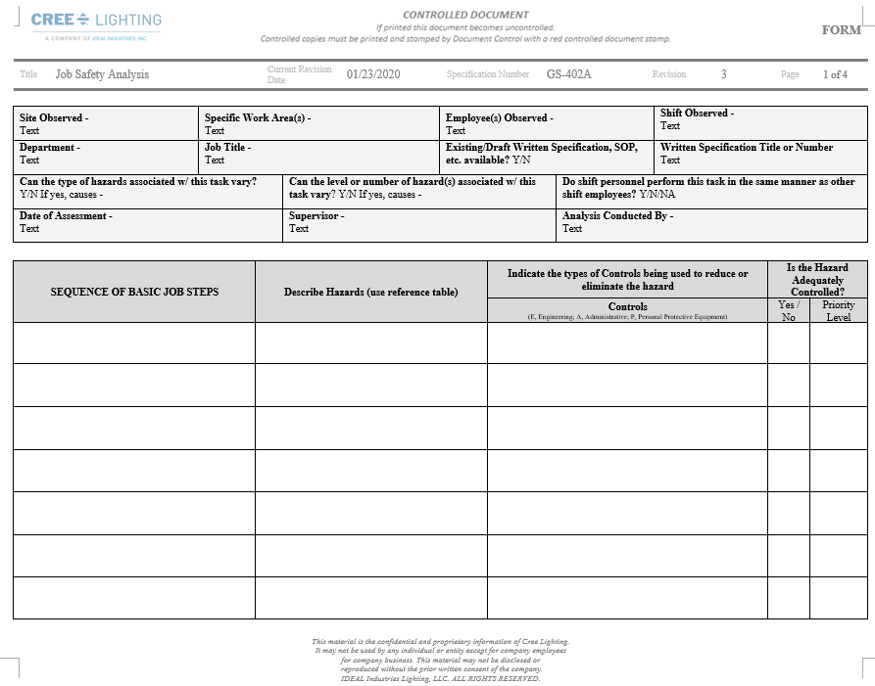 | 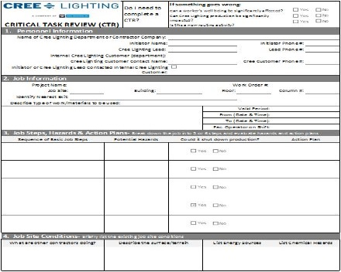

Training

Equipment and Tool Training
- You must be trained on each piece of equipment and tool you operate or use per the regulations applicable to the equipment or tool, or in compliance with good work practices.

Site-specific Training
- You must complete the Cree Lighting Contractor EHS Orientation and Test before receiving security clearance, and then annually thereafter.

Documentation
- Applicable education and experience records must be maintained by your company.
- When regulations require the employer verify that the employee understood the training, that verification must be documented.
- A written test or documented observation of the job performed will meet this requirement.

Unique or emphasized EHS Program Contractor Responsibilities and Requirements

Barricades
- Ensure barricades are effective for the weather conditions in which they are used, and substantial enough to dissuade the passage of persons or vehicles.
- Notify your sponsor 48 hours before closing off any road.
- Post appropriate (e.g., visible, lighted, etc.) road or other access closure signs if barricades are left overnight.
- Post warning signs at each point of possible entrance to the work area, stating the hazards within the area and contact information for the person responsible for the barricade.
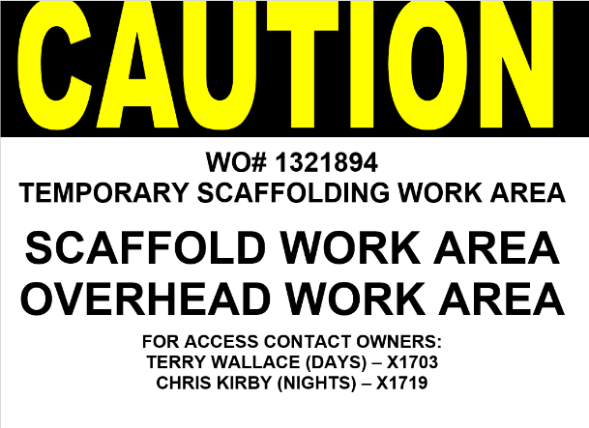
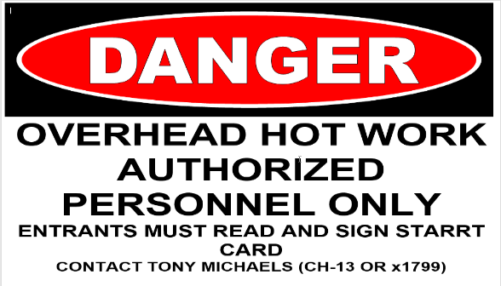

- Never attach barricades to items which must be accessed for safety, such as fire hydrants or extinguishers, valves, electrical panels, etc. Likewise, never allow barriers to limit access to these items unless doing so rightfully (e.g., live electrical panel being barricaded from others).
- Demarcating work areas
  - Use yellow* barricade “tape” when entry is allowed but caution is required (e.g. hoses on the ground, congestion, dusty, etc.)
  - Use red* barricade “tape” when entry is denied, or specific permission is required (e.g. open holes, overhead hazards, confined space, chemical fills, etc.)
  - “Tape” includes retractable webbing material, plastic folding panels, etc.
*Color may include other contrasting colors (specifically, black in combination with yellow or white in combination with red.)

Chemical Use
    - See Hazard Communication below.

Competent Person
- Designate a competent person when required by the applicable regulations (scaffolding, excavations, etc.).

Confined Spaces and Permit-Required Confined Space Entries (GS-411)
- This site contains confined spaces.
- Remain alert for hazards your sponsor identifies in any confined space and abide by any precautions or procedures implemented for the protection of employees in or near any permit required space.
- Not all confined spaces are identified with a label or sign.
- Your confined space-entry inspection procedure may allow reclassification of the entry as non-permit required. This procedure must be explained in your program.
- Prior to beginning work, obtain information regarding specific hazards from your sponsor, and following your pre-entry inspection process, inform your sponsor how the space will be classified.
- Permit-Required Confined Space Entries
      - Contractors engaged in permit space activities must exchange permit space program documentation with Cree Lighting.
      - Coordinate permit space entries with the sponsor, including when both Cree Lighting personnel and contractor personnel will be working in or near permit spaces.
      - Permit space entries will be made using the contractor’s written program and permit. All permit space programs must be approved by Environmental, Health, & Safety (EHS) prior to making entry. This review and approval should occur as part of the contractor’s approval process. Otherwise, the review must occur prior to the permit space entry.
      - When employees of more than one employer are working simultaneously as authorized entrants in a permit space, one primary person must be designated as the responsible entry supervisor for coordinating safe entry operations.
      - The entry supervisor must verify that local rescue services are adequate and available. Cree Lighting does not maintain an authorized confined space rescue team, so it is the contractor’s responsibility to ensure compliance with 1910.146(k). Your sponsor can assist in this verification by providing phone numbers for local rescue services.
- Provide equipment that is in good working order and operating per the manufacturer’s recommendations (e.g., calibrated, bump tested, inspected, etc.) and provide the associated documentation upon request.
- After the entry operations, provide your sponsor with a copy of the completed/cancelled confined space permit. Record and discuss with your sponsor any hazards confronted or created in the permit spaces during entry operations. These hazards can be described in completed or cancelled confined space permit, or on the Contractor Debrief Form (GS-441E) provided by your sponsor.

Cranes, Hoists, and Slings (GS-434)
- Crane operators shall possess a valid certification and have their certification on their person.
- Cranes must be inspected, and the inspection documentation must be available.
- Lift plans must be submitted to your sponsor at least three days prior to the job.
- Lift plans more than 75% of crane capacity are considered a critical lift and should be avoided.

EHS Walkthroughs
    - Cree Lighting personnel will perform walkthroughs at intervals necessary to measure performance with the requirements in this Handbook. These measures will include recognition of you and your company’s efforts towards EHS and Security as well as more traditional worksite inspection findings.
    - Results of these walkthroughs will be used in conjunction with other data for future ratings of your company.
    - Your company is expected to perform audits and inspections as needed to ensure excellent EHS performance at Cree Lighting.

Electrical Safety (GS-421) and Interruption of Electrical Service
    - Prior to performing electrical work, obtain authorization and a clear indication of which circuit is involved from your sponsor.
    - Live electrical work is only conducted through completion of an Energized Electrical Work Permit which must be presented to your sponsor.
    - Do not store equipment within 36 inches of an electrical panel.

Equipment and Tools
- Provide all equipment and tools required to perform the job safely, unless otherwise indicated by your sponsor. Cree Lighting retains the right to prohibit or restrict the use of tools and equipment determined to be unsafe.
- Do not use fuel powered equipment (generators, welding machines, etc.) inside buildings, or within 25 feet of the building exterior, or near building air intakes.
- Ground fault circuit interrupters (GFCI) are required on all extension cords.
- Space heaters must be powered by electricity.
- Inspections of tools and equipment:
      - OSHA-required tool and equipment inspections (forklifts, fall protection equipment, etc.) must be performed by a knowledgeable person and documented.
      - Tool and equipment users must perform pre-use visual inspections on tools and equipment (hand tools, electrical cords, ladders, etc.). These inspections do not need to be documented.
      - Tools and equipment that do not pass inspection must be taken out of service until corrected.

Fall Protection (GS-431)
- All personnel must be protected either by a standard guardrail or a personal fall protection system if exposed to a fall hazard of greater than
  - Six feet on construction sites; or
  - Four feet in all other areas.
- Fall protection is not required for persons climbing or working on portable ladders.
- Fall protection is required by all personnel in lifting devices.
- If a contract involves steel erection, submit a fall protection plan as required by OSHA.

Hazard Communication (CHEM-911)
- All chemicals must be approved by your sponsor before those chemicals are brought on site.
- You must advise Cree Lighting employees and other contractors of any hazardous chemical odors or impact to which they may be exposed. An approved Pre-Work Plan (PWP) and Communication Plan can be used for this purpose. The PWP and Communication Plan can be obtained from your sponsor.
- Safety Data Sheets (SDS) must be readily available for each hazardous chemical used at the jobsite and provided upon request.
- SDSs for chemicals at Cree Lighting to which you may be exposed are available from your sponsor or EHS.
- Cree Lighting uses and recognizes several different systems for labeling the identity or hazards of chemicals in use, storage or in delivery systems such as piping. Labels on incoming containers as provided by our suppliers, the Globally Harmonized System of labeling, the National Fire Protection Association’s Standard System for the Identification of the Hazards of Materials for Emergency Response (704 diamond) and the ASME A13.1 2015 pipe labeling standard.
- Performing a Safety Analysis (see below) will ensure that precautionary measures needed to protect you during normal operations and in foreseeable emergencies are in place.

Hazardous Energy Control
    - See Lock Out-Tag Out.

Hazardous Materials and Hazardous Waste
    - Obtain permission from your sponsor or project manager before storing hazardous material on Cree Lighting property.
    - Hazardous waste may not be transported off site unless approved by EHS.
    - All hazardous waste generated must be packaged and labeled in accordance with regulatory requirements.
    - Coordinate with Cree Lighting EHS on the proper storage, labeling, and disposal of hazardous wastes.

Hearing Protection and Noise Control
    - Hearing protection is required in the areas designated by the sponsor.
    - Contractor will be required to provide their own hearing protection.

Hot Work (GS-412)
    - Notify Cree Lighting sponsor and security if planning to perform hot work.
    - Obtain Cree Lighting’s Hot Work Permit (GS-412A) from your sponsor. You may supplement the Cree Lighting permit with your own.
    - Do not deactivate any fire protection system.
    - Provide sufficient fire extinguishers that are fully charged, properly inspected, tagged, and with pins intact. The extinguisher type must be appropriate for the potential fire type and work area. Minimum requirements are 4-A:60-B:C.
    - Keep the Hot Work Permit in the area until the final inspection is completed.
    - Immediately notify your sponsor and security upon completion of the hot work.
    - Return completed permits to your sponsor.

Housekeeping
    - Keep entry and exit routes to work areas, and emergency exit routes, clear always.
    - Keep all work areas orderly, clean and free of hazards.
    - For work extending across multiple days, properly store all material, tools, etc. between work shifts.
    - Work areas found to violate our housekeeping standards may be shut down.

Incident Reporting and Notifications (IM-621)
    - Inform your sponsor immediately upon learning of any incident on site that has caused or is likely to cause fatalities, injuries, property damage, spills or releases to the environment, or regulatory non-compliance.
    - Notify your immediate supervisor of environmental, health, or safety issues or concerns you observe.
    - The contractor is responsible for
      - investigating accidents, incidents, and unsafe conditions involving their employees;
      - immediately reporting the circumstances to your sponsor; and
      - providing Cree Lighting with a copy of the completed investigation report upon request.
    - Forward all outside inquiries and requests for information to your sponsor. Requests related to environmental, health and safety must be forwarded to EHS.
    - Contact your sponsor immediately if OSHA (Occupational Safety & Health Administration), EPA (Environmental Protection Agency), or WI DNR (Wisconsin Department of Natural Resources) personnel show up.
    - Spills and Leaks
      - Immediately notify your sponsor of spills, or leaking pipes or equipment. This includes spills and leaks observed in other areas.
      - Take all alarms seriously and follow specific instructions issued by emergency responders (e.g., ERT members, Security, outside response personnel, etc.)
      - If so equipped and trained in accordance with 29CFR1910.1020; contain and clean up spills in accordance with the Safety Data Sheet and environmental regulations.
      - Your company is accountable for the costs of clean up and disposal of hazardous material resulting from releases which you are found to be responsible.

Inspections (IM-613) and Audits
    - Contractors are required to cooperate during audits, and correct deficiencies observed in their areas of responsibility during audits within the time specified.

Ladders (Portable) (GS-432)
    - All ladders brought onto the job site shall be in good condition, free of structural defects, and rated no less than ANSI A14, Type I (at least 250-pound capacity). Type II or III ladders are prohibited.
    - The ladder type must be appropriate for the task.
    - Fiberglass or other insulative ladders must be used when working with electrical circuits that might be live.
    - Contractors will follow all ladder safety rules.

Lasers (OH-344)
- Lasers must comply with the applicable provisions of the OSHA Construction Standard.

Life and Fire Safety
- Fire Suppression Systems
      - If impairment of a fire suppression system is required, it must be requested 48 hours in advance by your sponsor prior to the work beginning. Ensure that your sponsor has had the suppression system disabled prior to beginning such work.
      - For work that will be performed in the close vicinity of a fire sprinkler, request a survey of the work area 48 hours in advance by your sponsor so that they can determine if the system should be impaired.
      - Notify your sponsor as soon as work is completed so the system can be reactivated.
- Smoke Detectors
      - For work that will generate smoke or dust, notify your sponsor 48 hours in advance to request a survey of the work area for smoke detection equipment.
      - If impairment of the smoke detection system is required, it must be requested by your sponsor or project manager prior to the work beginning. Ensure that your sponsor has had the detection equipment disabled prior to beginning such work.
      - Notify your sponsor as soon as work is completed so the system can be reactivated.
    - Fire Extinguishers (GS-413)
      - Contractors must:
        - ensure that fire extinguishers are not blocked.
        - be trained on proper fire extinguisher use if applicable
      - Contractors should bring own fire extinguisher if engaging in hot work activity

Lock Out – Tag Out (LOTO) (GS-422)
- Contractors controlling hazardous energy sources must have a written LOTO program.
- All contractor Lock Out Tag Out (LOTO) programs must be approved by EHS prior to performing work. This review and approval should occur as part of the contractor’s approval process. In emergencies, the review can occur prior to the lock out.
- Use your company’s lock and tag where such applications are required.
- The LOTO tag must include the name of the person applying a LOTO and the name of the company and must be printed legibly. Preferably, the person’s cell phone number would also be included in the event the lock needs to be removed.

Material and Equipment Shipment and Storage
    - Cree Lighting employees are not authorized to unload contractor’s materials. The contractor must make their own arrangements for unloading their material.
    - Coordinate shipments with sponsor to avoid interfering with site operations.
    - Place material in the lay-down area designated by your sponsor.
    - On-site storage of hazardous material requires sponsor approval.
    - Do not ship or receive hazardous materials on Cree Lighting sites without the approval of EHS.
    - Contractors involved in the transportation of hazardous material are responsible for ensuring regulatory compliance.

Motor Vehicles (Including Forklifts, Scissor Lifts, Golf Carts, and Personnel Lifts)
    - The speed limit in Cree Lighting parking lots and facility grounds is 5 mph.
    - You may not use Cree Lighting owned or leased motor vehicles, including fork lifts, golf carts, scissor lifts, personnel lifts, or other tools, unless special circumstances allow and are permitted by EHS.
    - Drivers must have proof of applicable operator certification (e.g. forklift/personnel lift driver’s license) on them while using the lift.
    - Inspection forms must be kept on each vehicle until the next inspection is performed.
    - When operating vehicles on Cree Lighting property, you must
      - keep your feet on the floor of the vehicle and your body parts inside the vehicle while the vehicle is in motion;
      - ensure personnel and cargo do not exceed the weight limit of the vehicle;
      - not talk or text on a phone, or use ear buds, head phones or other listening devices;
      - obey all traffic signs; and
      - properly secure cargo.
    - Spotters are required when
      - moving oversized loads;
      - moving in tight spaces;
      - a fork lift driver cannot see over the load and must drive forward; or
      - large/long equipment is attached to a fork lift (e.g. boom, etc.).
    - Equipment (e.g. boom, drum holder, etc.) attached to a fork lift must properly secured to the fork lift.
    - Fall protection must be worn while on scissor lifts (This is a requirement unique to Cree Lighting).
    - Contractors’ golf carts on site must be
      - equipped with horn and back up alarm; and
      - parked or stored in a safe location.

Non-Destructive Testing (NDT)
- Contractors performing NDT must be certified per the requirements of the American Society for Nondestructive Testing and provide NDT certification documents with the prequalification package.
- A Level III inspector must be responsible for supervising the work of Level I and II personnel.

Personal Protective Equipment (PPE)
- PPE must be provided by the contractor.
- PPE should be inspected for any damage or defects before each use. Any damaged PPE will be taken out of service and replaced.
- When the use of specific PPE requires other safety program elements (e.g. respirator fit tests), the contractor must provide:
      - Properly trained and certified personnel; and
      - Training, inspection and certification records upon request.

Petroleum Contained in Equipment
- Equipment brought on site that contains oil or fuel (e.g. generators, chillers, lawn mowers) must be provided with adequate secondary containment, such as a portable spill berm, a berm of oil absorbent, or a boom system.
- All containment systems must be inspected daily, properly maintained, and robust enough to contain the material during a typical weather event.

Radios and Other Communication Devices
    - All methods of electronic communication must be approved by your sponsor for the specific area in which you are working.
    - Two-way radios must be provided by Cree Lighting. Do not bring your own.

Road Maintenance
- Each contractor must maintain roads which are affected by the contractor’s work.
- Clean dirt, mud, concrete, spoil, refuse, debris, etc. from the roadways, access ways and walkways.
- When debris is created, clean up the area by the end of the work day or sooner if requested.

Roof Safety
    - Roof access is for business purposes only.
    - Never go on the roof alone, always work using the buddy system.
    - Do not work on or access roofs during times of severe weather or other conditions that would make working in outdoor conditions inherently unsafe (e.g. extreme heat, thunderstorms, high winds etc.).
    - If work is performed less than 15 feet from the roof’s edge, conventional fall protection is required.
    - Overview emergency preparedness procedures with all workers involved prior to doing work on the roof.
    - Establish a means of communication with someone who is not on the roof, who can notify workers on a roof of an emergency and the potential need to evacuate. Emergency situations may include building evacuations, impending severe weather and others.

Safety Meetings
- Safety Meetings are required for all contractor jobs performed at Cree Lighting.
- These meetings can be in any form and must be held at least weekly.
- All sub-contractors must be included in these meetings.
- Attendance, as well as topic, must be documented.

Smoking
    - Smoking is prohibited on Cree Lighting property, including while in your vehicle.

Spills and Leaks
    - Immediately notify Cree Lighting Security at 262-721-1400 of spills, or leaking pipes or equipment. This includes spills and leaks observed in other areas. The report must include the nature of the spill, the location of the spill, the size and extent of the spill, the material involved (if known), and personnel injuries.
    - Take all alarms seriously and follow specific instructions issued by emergency responders (e.g., ERT members, Security, outside response personnel, etc.)
    - If so equipped and trained in accordance with 29CFR1910.1020; contain and clean up spills in accordance with the Safety Data Sheet and environmental regulations.
    - Your company is accountable for the costs of clean up and disposal of hazardous material resulting from releases which you are found to be responsible.

Utilities and Sanitation Requirements (Construction Sites)
- Provide all the following support services on all construction sites, except for those that the sponsor agrees will be provided by Cree Lighting:
      - Area lighting
      - Compressed air
      - Power for small tools (110 VAC)
      - Sanitary requirements (drinking water, toilets and washing facilities)
      - Telephone service

Water Pollution Control
- Process Water (water used in production processes) and Sanitary Sewer Discharge
      - Ensure no liquid or solid wastes are released to any indoor water or sanitary (bathroom) sewer drain without prior approval from EHS. All spills of any material, solid or liquid, must immediately be reported to Security and EHS.
- Storm Water Pollution
      - If conducting outdoor activities, ensure contractor staff understand that no liquid or solid material is allowed into any outside drain, storm drain, or the ground around construction areas, except with specific prior approval from EHS.
      - For any container holding any liquid or solid material that might wash into an internal drain, storm drain, the adjacent pavement, or soil, provide enough secondary containment for 110% of the container contents.
      - Store any material having a potential to contaminate storm water under cover. This includes material covered with oils or greases, wooden pallets, etc.
      - Do not discharge water contaminated by contact with solid or liquid material to storm drains.
      - Obtain prior EHS approval before pressure washing, concrete cutting, or rinsing concrete mixers, and follow EHS guidance on control of the resulting residue. All concrete operations must include a slurry washout station suitably lined with plastic or other containment to prevent slurry runoff from concrete washing.
      - Do not allow water drained from process equipment or cooling towers into storm drains without prior approval from EHS.
      - Take appropriate silt fencing and erosion control measures during construction activities.
      - For site construction work, contractors must obtain the required state permits for land disturbance when disturbing one acre or more of land.

Records
  - Provide records and proof of documentation upon request. These records may include hazard assessments, job work instructions, equipment calibrations and inspections, training records, Safety Data Sheets, and other documents as required by regulation.
  - Provide the requested documentation within a reasonable time. Reasonable time will be determined by regulatory requirement. When records are expected to be readily available to an employee under a regulatory requirement, be prepared to provide the documentation within a few minutes, but with other records that may be stored off-site, it is understood that producing the records may take longer.
  - When specified by your sponsor, provide hours reporting and documentation.

Security and Site Access
  - Contractors wanting to perform work during
    - The weekday hours of 5:30 am and 4 pm (Central Daylight Time) should check in with Security to get a contractor badge. Once work is complete, the access badge should be returned to Security.
    - The weekday hours outside of 5:30 am and 4 pm (Central Daylight Time) and/or the weekend must make arrangements with Cree Lighting Sponsor and Security to secure contractor access badge BEFORE coming on site. Once work is complete, the access badge should be returned to the badge drop off box located at the west atrium security desk.
  - Contractors must complete the following security paperwork for unescorted access:
    - GS-441K - Contractor Security Requirements – Company Acknowledgement Form
    - GS-441L - Contractor Security Requirements – Employee Consent Form
    - GS-441M - Contractor Security Requirements – Attachment A Letter
    - GS-441N - Contractor Security Requirements – Access Control Acknowledgement Form
    - GS-441O - Contractor Security Requirements – Non-Disclosure Agreement (NDA)
    - GS-441P - Contractor Security Requirements – Visitor Statement Form
    - GS-441Q - Contractor Security Requirements – Sample Proof of Insurance
      - Failure to return all required security documents will require full-time escorting by Cree Lighting sponsor until completed.
  - Always carry a valid photo ID (driver license, passport, state issued photo ID).
  - Your Cree Lighting badge must always be visibly displayed on the upper body, any location from the waist and above.
  - Ensure every member of your work group has a Contractor Badge, including “Outside Only” personnel.
  - Ensure ALL Daily Contractor Badges are returned at the end of the work day.
  - Never allow anyone to use your Contractor Badge.
  - Do not tailgate or piggyback through entry points, such as doors, roll-up doors, gates, barriers or turnstiles.
  - Never provide escort functions for anyone not appropriately checked-in with Security.
  - Contact your Cree Lighting Sponsor or project manager any time you don’t have the appropriate access.
  - Never take any photos or videos while on any Cree Lighting Campus. Ask your sponsor to take the picture.
  - Never prop-open a door or gate without prior coordination with your Sponsor or project manager.
  - Escorting
- You must possess a photo badge and escort privileges to escort a visitor.
  - You may take your visitor to those areas you are authorized to access, providing the visitor has a need to be in that area.
  - You may not engage in any work nor other activity that could interfere with your primary responsibility of maintaining positive control of the visitor.
  - Your visitor must be considered essential for site operations and as approved by your Sponsor or Project Manager.
  - You are responsible for ensuring that your visitor/s comply with site procedures and policies. If an escorted visitor is in violation of any site policy/procedure, notify Security immediately.
- The only actions allowed by escorted employees are non-hazardous; such as reviewing a job, evaluating a job, bidding a job, etc. No work requiring tools may be done by an escorted person.
- Escorted individuals’ must
  - have a Visitor badge
  - stay with their escort

Document Revision History
Date | Rev. | DCN # | Change | By: | Approval
09/14/2017 | - | DMS | Document Origination | B Edwards- C Markgraf | DMS
02/08/2019 | 1 | DMS | Added EHS Walkthroughs, Escorting, Life and Fire Safety, Radios and Other Communication Devices, and Security and Site Access to the Handbook | C Markgraf | DMS
07/18/2019 | 2 | DMS | Updated name from Cree to Cree Lighting. Changed document title from Contractor EHS & Security Handbook – RAC to Contractor EHS & Security Handbook – WI | C Markgraf | DMS
Revisions above reflect changes made to GS-442.2. Revisions hereafter reflect changes to GS-441.2.
09/23/2020 | 3 | DMS | Converted to Cree Lighting Template. Updated Security hours from (6 am – 2 pm) to (5:30 am – 4 pm). Renamed specification number from EHS-GS-442.2 to GS-441.2 to group with contractor safety program. | C Markgraf | DMS
06/14/2021 | 4 | DMS | Added fire extinguisher requirements to section 8.20. Added security documents to section 10.2. | C Markgraf | DMS

